**Tutorial 37: Vue Router – Folder Structure**

In this tutorial we will focus on best practices to organise our folder structure inside a Vue application. The idea is to make sure that folder structure is constant and logically so that it is easy to find that we are looking for when coding or maintaining the application.

Make sure **Tutorial 36** is complete to be able to move on to this tutorial or clone the [vue3-firebase-course](https://github.com/younggrasshopperza/vue3-firebase-course) repository and go to branch called **Tutorial-36** and navigate to the young-grasshopper-jobs folder..

**Step 1:** Inside the views folder create a Job.vue file and set up the Vue component by type vue in component.

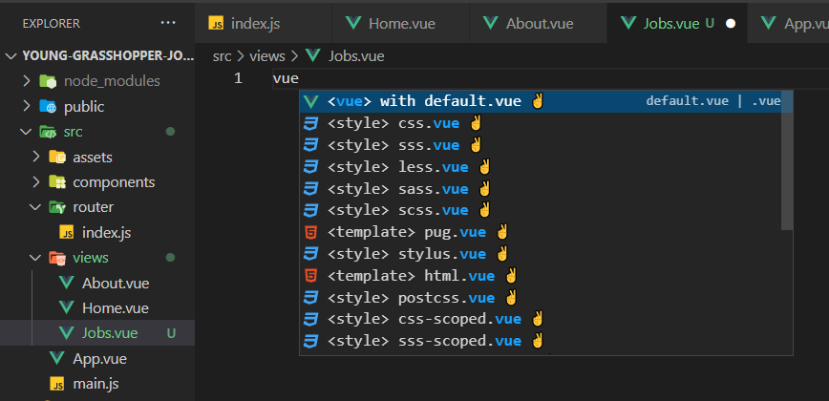

Inside the script tag create the data property that returns an array with an object of job descriptions.

Look at the example below (**Between Line 7 and line 15**):

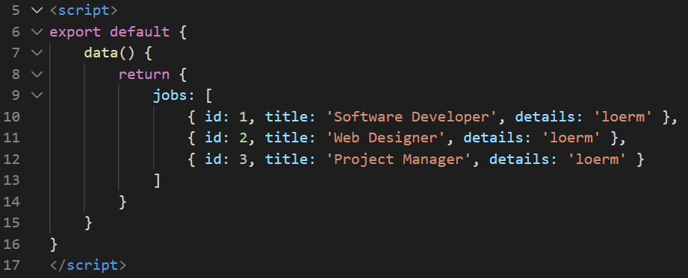

**Step 2:** Inside the Job.vue file, add an h1 tag with the title Jobs. Output the jobs data property inside a div using a v-for.

Look at the example below (**Between Line 2 and line 5**):

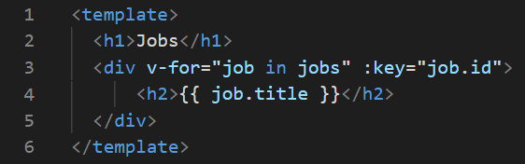

We now need to register the component to be a route so that we can navigate to the page and display it on the screen.

**Step 3:** Inside the router folder, in the index.js file, inside the array of routes, below the about route object, create a new object for the jobs component. Include the keys, path which has the value “/jobs”, name which has the value “Jobs”, and component which has the value “Jobs”. You will need to import the component so that we can access the component.

Look at the example below (**Line 4 and between line 17 and line 21**):

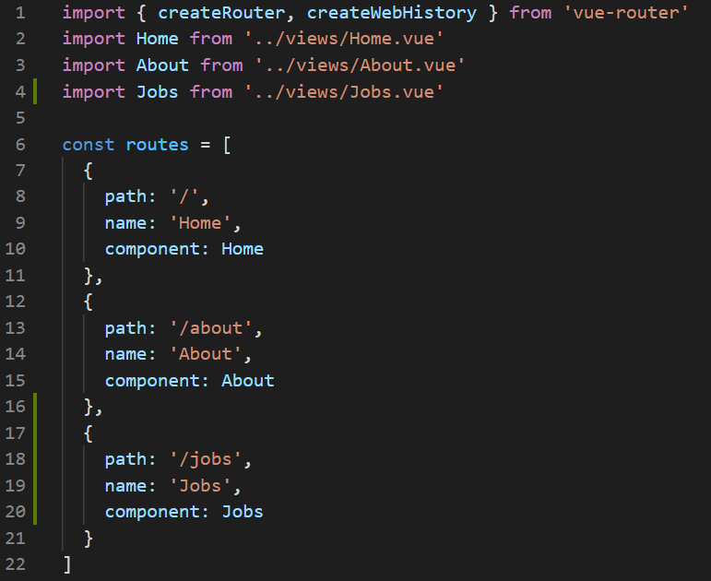

**Step 4:** Inside the App.vue file, create a new link in the div with the id of nav under the about.

Look at the example below (**Line 5**):

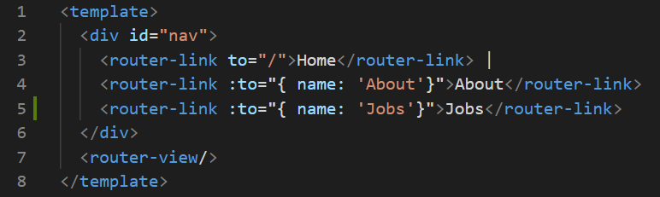

**Output:**

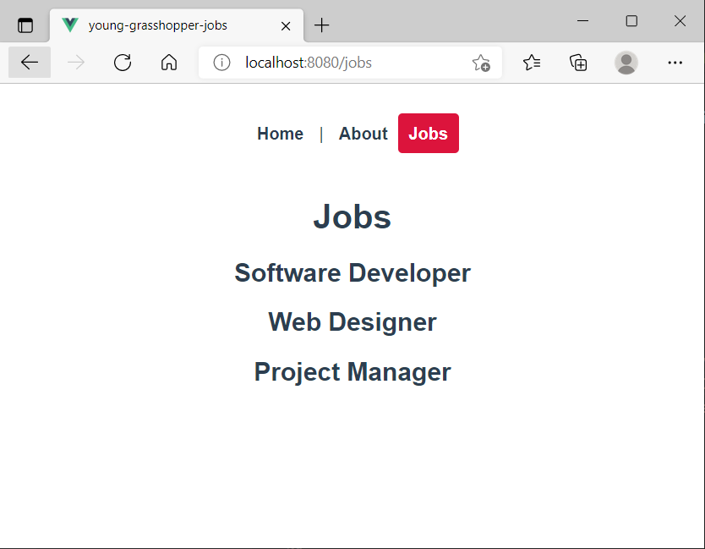

**Step 5:** Inside the view folder, create a subfolder called Jobs.

Move the Jobs.vue file inside the JobDetails folder. Create a file called JobDetails.vue.

These files are similar and we will be using more or less the same type of data so it makes sense that we group the components together in a folder.

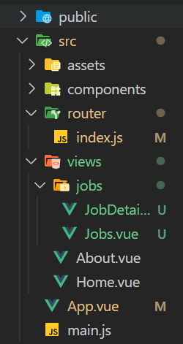

Inside the router folder, in the index.js file, change the file path of the Jobs component to direct into the correct file inside the new subfolder called Jobs.

Look at the example below (**Line 4**):

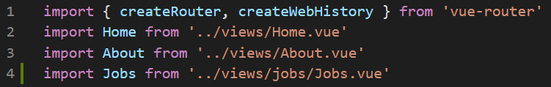

**You can view the code snippets from the** [**vue3-firebase-course**](https://github.com/younggrasshopperza/vue3-firebase-course) **repository under the Tutorial-37 branch**.